**RUNNING SERVER**

SO NOW LET’S GO AHEAD AND RUN OUR SERVER TO DEPLOY OUR PROJECT, WE MUST ENTER INSIDE DJANGO PROJECT AND START OUR PYTHON SERVER THROUGH ***manage.py*** FILE WITH ***python manage.py runserver 0.0.0.0:8080*** COMMAND, LOOK AT WE’VE SPECIFIED A RANGE OF IP DIRECTIONS AND A SPECIFIC PORT WHICH OUR SERVER WILL RUN:

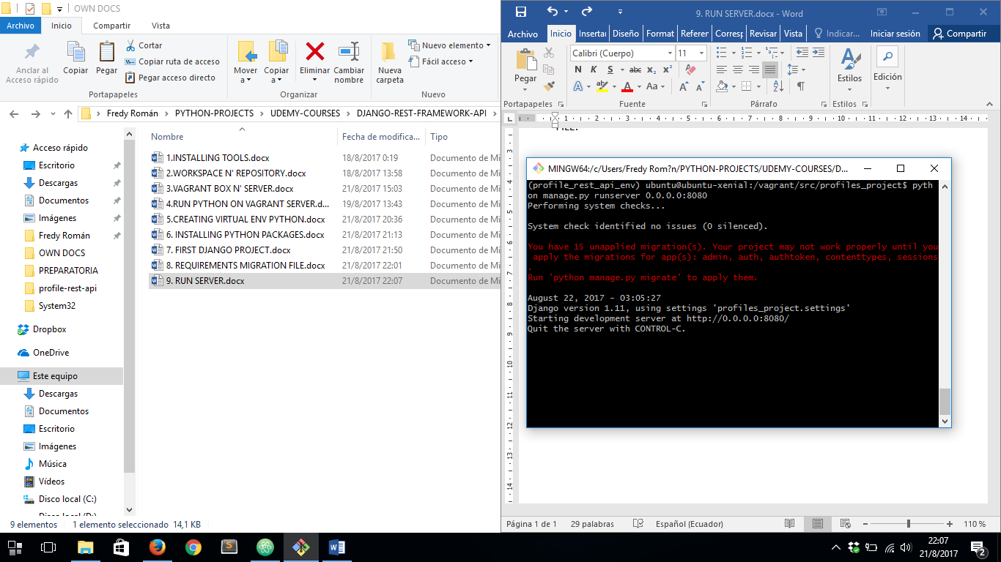

FINNALY LET’S GO AHEAD AND OPEN OUR APP ON A BROWSER:

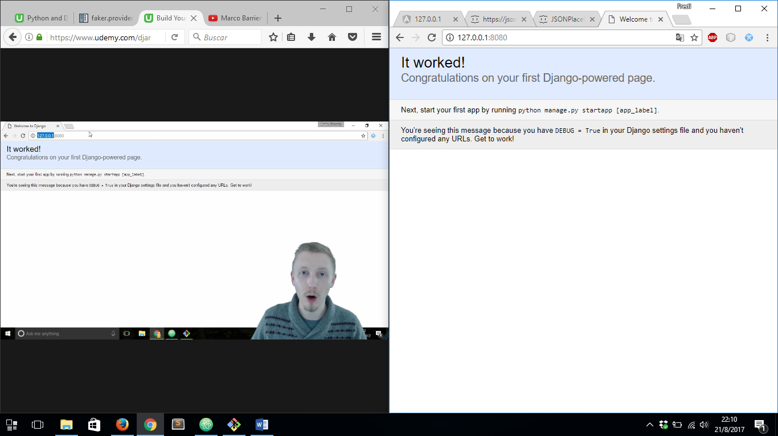

LET’S TAKE A LOOK INSIDE ***Vagrantfile*** THEN WE WILL SEE NEXT LINE:

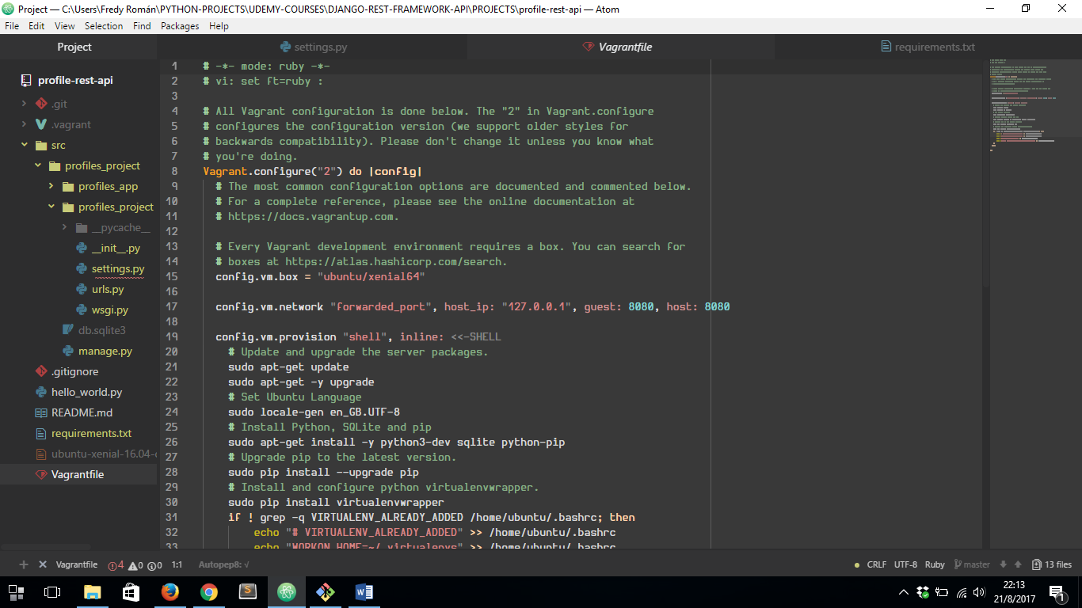

WE’VE SEEN IN THAT LINE ONE IMPORTANT CONFIGURATION, WHICH MEANS WE AS A GUEST WILL ABLE TO ACCESS TO OUR APP INTERFACE VIA 127.0.0.1 IP AND 8080 PORT, AND OUR VAGRANT SERVER WIL RUN ON PORT 8080**.**